**NAME:**

**SAP ID:**

**DIV:**

**TOPIC:** DE

**Experiment Number:** 5

**DATE:**

**AIM: -**

Design and verification of the truth tables of Half and Full adder, Half and Full subtractor circuits.

**APPARATUS REQUIRED: -**XOR gates (IC 7486), AND gates (IC 7408), Wires, Breadboard, power supply,LED.

**THEORY:-**

**Half adder:**

A half adder has two inputs for the two bits to be added and two outputs one from the sum ‘ S’ and other from the carry ‘C’ into the higher adder position. Above circuit is called as a carry signal from the addition of the less significant bits sum from the X-OR Gate the carry out from the AND gate.

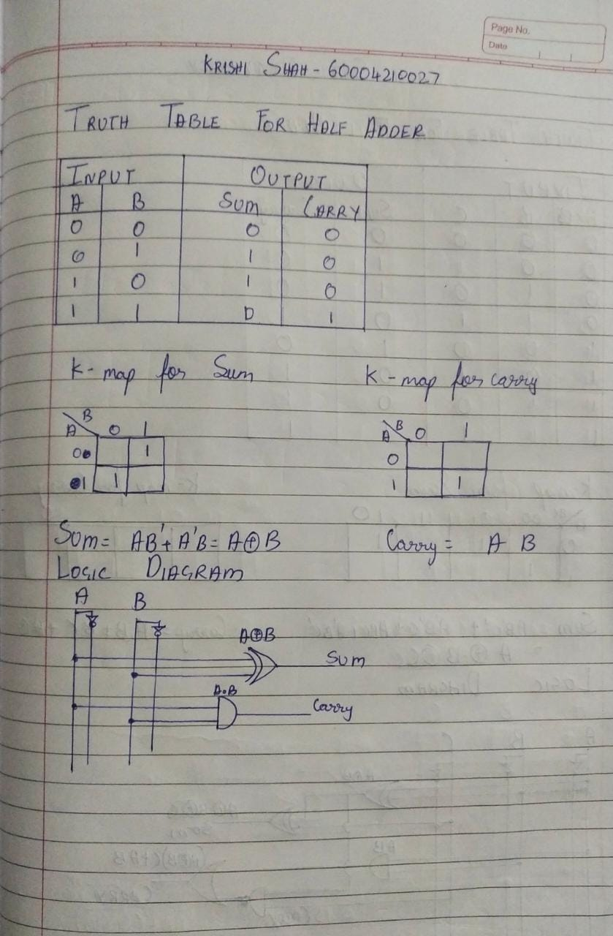

**Full Adder:**

A full adder is a combinational circuit that forms the arithmetic sum of input; it consists of three inputs and two outputs. A full adder is useful to add three bits at a time but a half adder cannot do so. In full adder sum output will be taken from X-OR Gate, carry output will be taken from OR Gate.

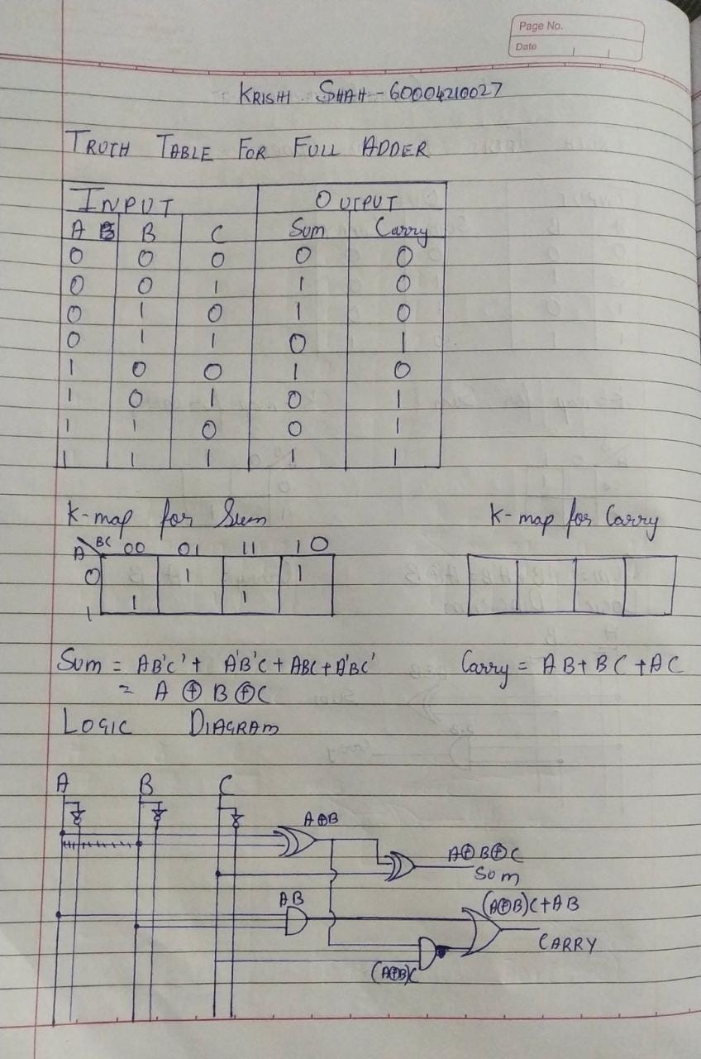

**Half Subtractor:**

The half subtractor is constructed using X-OR and AND Gate. The half subtractor has two input and two outputs. The outputs are difference and borrow. The difference can be applied using X-OR Gate, borrow output can be implemented using an AND Gate and an inverter.

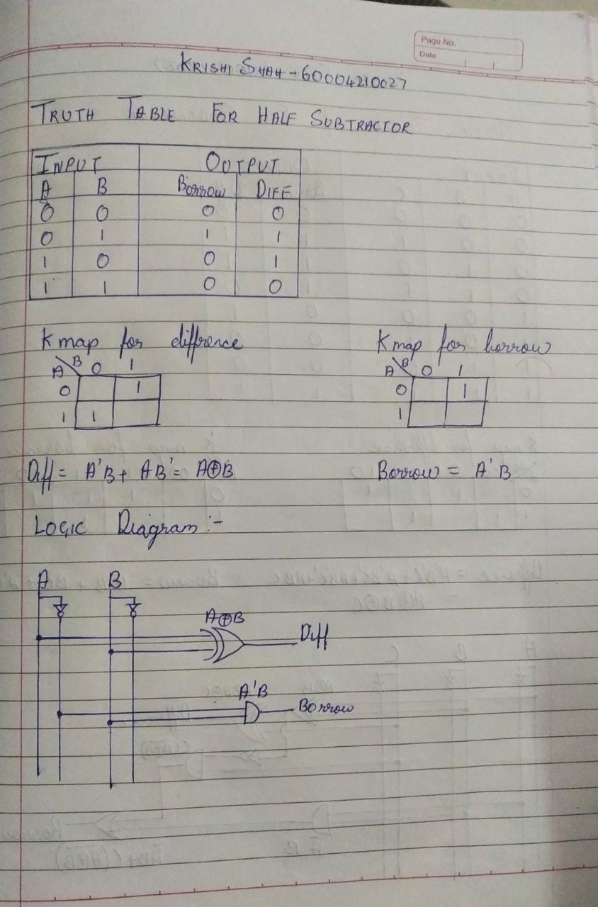

**Full Subtractor:**

The full subtractor is a combination of X-OR, AND, OR, NOT Gates. In a full subtractor the logic circuit should have three inputs and two outputs. The two half subtractor put together gives a full subtractor .The first half subtractor will be C and A B. The output will be difference output of full subtractor. The expression AB assembles the borrow output of the half subtractor and the second term is the inverted difference output of first X-OR.

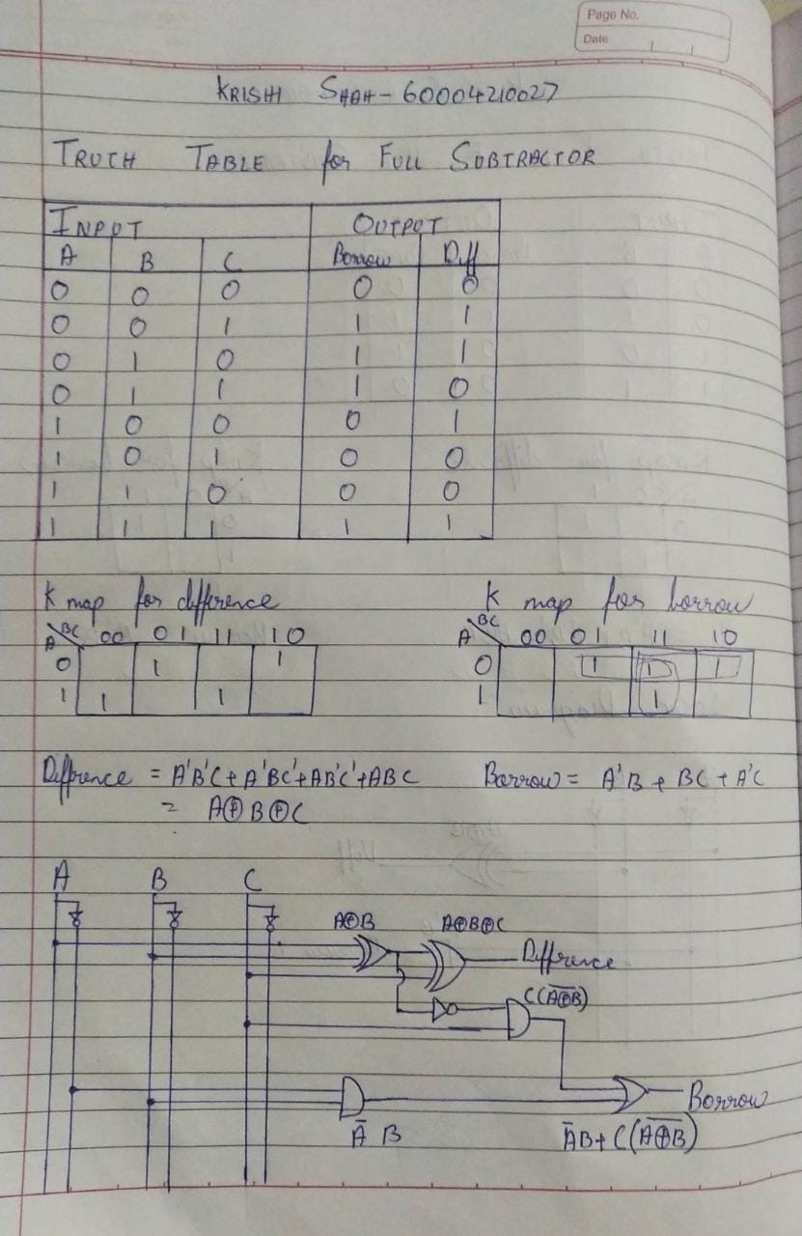

**PROCEDURE:**

(i) Connections are given as per circuit diagram.

(ii) Logical inputs are given as per circuit diagram.

(iii) Observe the output and verify the truth table.

**RESULT:-**

Thus the half adder, full adder, half subtractor and full subtractor was designed and their truth table is verified.